**Leader Overview**

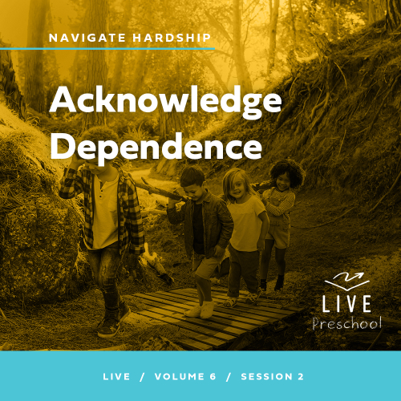

**Volume Overview**

**Navigate Hardship**

*Life is hard, even for believers. We all know it or discover it soon enough. Life tests our patience, our hope, and our sense of God’s presence. But we are not left hopeless in our challenges. God’s presence is more certain than even our hardships. Still, there are times in life that we need to be reminded that He is present. It’s in hardships that we learn to recognize it. We also learn to depend on God, to wait, and to look forward to His rescue.*

**Session Overview**

**Acknowledge Dependence**

*In this* **Live** *session, preschoolers will discover that we can always trust God, even when a situation may feel hopeless. They will explore the story of the baby promised to Elizabeth and Zechariah, and how we can still trust God’s message even when it’s hard to believe. Preschoolers will continue to learn more about who God is and about how He is always with us when we face hard times.*

**Bible Lesson**

Zechariah and Elizabeth’s Wait Is Over

[Luke 1:6–25](https://ref.ly/logosref/Bible.Lk1.6-25), [57–66](https://ref.ly/logosref/Bible.Lk1.57-66)

**Faith Fact**

I can trust God to answer.

**Faith Verse**

[Psalm 34:19](https://ref.ly/logosref/Bible.Ps34.19) (NLT)

The righteous person faces many troubles, but the Lord comes to the rescue each time.

**Preparing for the Session**

**Leader Preparation Time: 20–25 Minutes**

|  |
| --- |
| ***You Will Need***  ***Preservice Activities***  *• Toys*  *• Smartphone with timer*  *• Fruit-flavored ring cereal or other multicolored snack*  ***Large Group***  *• Bible*  *• Worship songs (Song suggestions: “Boom” Lyric Video by Go Kids Worship; “For All My Days” Lyric Video by Gateway Kids Worship; “Jump” Lyric Video by Go Kids Music)*  *• For groups not using a phone or tablet only, add:*  *• Projector or TV*  *• Laptop*  *•* ***Faith Fact Sound*** *video (bell ringing)*  *•* ***Faith Fact Slide***  *•* ***Faith Verse Slide***  *•* ***Faith Verse Video***  *•* ***Bible Lesson Video A***  *•* ***Bible Lesson Video B***  ***Small Group***  *• Jingle bell, one per kid*  *• Yarn*  *• Scissors*  *•* ***Small Group Activity Page****, one per kid*  *• Pencils or pens, one per kid*  *• Crayons or markers*  *• Smartphone*  *• Someone ready to answer your call*  *To access session content and videos from a computer, visit:* [***BibleEngagementProject.com/downloads***](https://bibleengagementproject.com/downloads) |
| ***Getting Ready***  ***Preservice Activities***  *• Set out toys and snacks.*  ***Large Group***  *• Download videos and slides if needed.*  *• Select worship song(s) and have them ready to play.*  ***Small Group***  *• String one bell on a length of yarn for each kid.*  *• Print copies of the* ***Small Group Activity Page****, one per kid.*  *• Ask someone to be ready to answer the phone when you call. They don’t have to be present in the room.*  ***First time leading* Live *for Preschool? Check out the*** [**Facilitator Guide**](https://0b769b0ed3569ef9d18b-f88d8272f61086866d50d048b43ef630.ssl.cf2.rackcdn.com/sites/biblengagementproject/Listen_Facilitator_Guide.pdf)**.** |

**Preservice Activities**

*See what’s needed at the beginning of the session.*

**Bible Story Warm-Up**

How many of you like to run fast? *(Group response)* Let’s see how fast you can run in place while I time you.

• *Time kids for one minute while they run in place.*

I used a stopwatch on my phone because it’s used to measure time. One is often used in races to see who can run the fastest. We can also use it to time how long it takes to do something. Would you like to do another challenge? *(Group response)*

Awesome! I need everyone to stand up and put your arms straight out to your side. You’ll look like the letter *T*. Now I’m going to time you to see if you can keep your arms up for one minute. Let’s play.

• *Start the timer. Then, hold your arms up like the kids.*

• *Encourage kids to not give up. If they put their arms down encourage them to put them back up as quickly as possible.*

Wow! Great job. Both of those activities took the same amount of time. Did it feel like they did? (*Group response)*

Which minute seemed to go slower?

Is waiting for time to be up hard or easy?

What is something you’ve had to wait a long time for? *(Be ready with your own story of waiting on something—child to be born, birthday, Christmas, vacation, etc.)*

I think we can agree the minute when we were waiting to put our arms down felt way longer than the minute spent running in place. Sometimes waiting can seem really hard. Today, we’ll hear a Bible story about two people who had to wait a long time for God to answer a prayer. We’ll find out more from Lizzy and Grandpa soon.

**Snack**

**Fruit-Flavored Ring Cereal or Other Multicolored Snack**

We have a fun snack today, but it’s going to require you to help me answer some questions before you can eat it. If you think you can wait to eat it, raise your hands in the air and wave them around. *(Group response)* Awesome!

• *Hand out snack.*

• *Adapt suggested colors to match the snack you’re serving.*

I’ll give you two options for each question, and you’ll hold up the color of the one that you like more. Ready? *(Group response)*

Blue or pink? If you like dogs more, hold up a blue piece. If you like cats more, hold up a pink piece. *(Group response)*

Orange or yellow? If you like swimming more, hold up an orange piece. If you prefer riding bikes, hold up a yellow piece. *(Group response)*

Green or purple? If you like watching videos more, hold up a green piece. If you prefer playing video games, hold up a purple piece. *(Group response)*

• *Add as many additional questions as you’d like.*

• *Allow the kids to eat their snack freely after you’ve asked the questions.*

You all had some great answers to my questions. Today, we’ll find out who we can always trust to have answers for us. It’s going to be a great day of learning together. I can’t wait to learn more from God’s Word with you!

**Free Play**

*Any extra time can be spent playing with toys.*

**Transition**

*A few minutes before service begins have kids make their way to the large group area and sit in their designated areas.*

**Large Group**

**25 Minutes**

*See what’s needed at the beginning of the session.*

**Introduction**

Hi, friends! It’s wonderful to see all of you and your smiling faces today! Can you show me your biggest smile? *(Group response)* This is my biggest smile *(demonstrate)*. Wow, my cheeks hurt a little bit! I hope you saved some of your smiling because we’ll have a great day together.

Raise your hand if you have a little brother or sister. *(Group response)* Do you remember when they were just babies? *(Group response)* Today, we’ll learn about a husband and wife who really wanted a baby. They had waited for a really long time. *(Hold up the Bible.)* Then, God sent a message to them by a special messenger. Does anyone have a guess about who the messenger could have been? *(Allow responses.)* It was an angel!

**Faith Fact**

The husband and wife had probably prayed many prayers asking God for a baby. Even though they had waited a long time for an answer, God heard every prayer. We can always trust God to hear every one of our prayers. He always answers, too, but it may not always be how we want. Sometime God answers our prayers quickly and gives us what we pray for. Sometimes He says no because He knows what is best for us. Other times He asks us to wait for the answer to come later. That’s our Faith Fact today. **I can trust God to answer.**

• *Show the* ***Faith Fact Slide.***

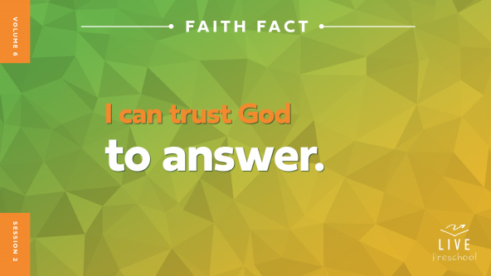

Let’s tap our feet really lightly while we say each word this time. **I can trust God to answer.** Now, let’s stomp our feet with every word. **I can trust God to answer.** You have some strong feet. Good job!

**Bible Time**

This is one of my favorite parts of our time together. We get to learn more about God and what He tells us in the Bible. Who is our friend who tells us Bible stories? *(Allow responses.)* Yes, Lizzy! Let’s see what she’s doing.

• *Play* ***Bible Lesson Video A****.*

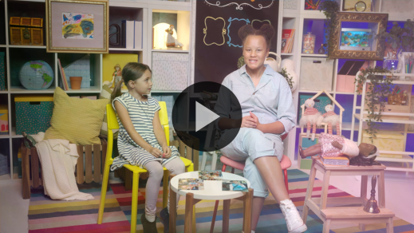

What a great clue to ask us about! We’ll need some time to think about it, so let’s move into worship. Then, we’ll come back to our Bible story.

**Worship**

I love to worship God because it helps me remember how kind and loving He is. He is big and strong, and He is always with me.

**Praise**

Who wants to thank God for His great big love? Stretch your fingertips high into the sky. *(Group response)*

Are you glad God hears every prayer we ever pray? Clap your hands together like you’re praying. *(Group response)*

Who wants to thank God for answering prayers? Squat down as low as you can. Then, let’s rise up together. *(Group response)*

**Sing**

I love to praise God with you! Let’s use our voices to sing to and worship God. Wave your hands at me if you love music as much as I do *(demonstrate)*. Then, let’s sing together.

• *Lead the kids in singing one or two songs. See song suggestions at the beginning of the session.*

**Prayer**

Today, we’ve talked about how God answers prayer. Let’s pray to our great and loving God. Can you bow your head, fold your hands, and close your eyes?

|  |
| --- |
| *Dear God, thank You that You hear every thought we think and every word we pray. You are so strong, and You always want what is best for us. We say yes to You and what You want us to learn today. Amen.* |

**Bible Time cont’d**

• *Start* ***Bible Lesson Video B*** *and pause on the image of the two choices.*

Can you guess what time it is now? *(Group response)* It’s Bible story time. We get to see what happens next in our story. Let’s put on our thinking caps *(demonstrate).* What do you think? Do you think Zechariah trusted the angel’s message from God? *(Point to angel graphic on screen.)* Or do you think Zechariah didn’t believe the angel’s message? *(Point to angel graphic with X over it on screen.)*

If you think Zechariah trusted God’s message, nod your head up and down to show yes. If you think Zechariah didn’t think God’s words were possible, shake your head back and forth to show no. Ready? Choose your answer.

• *Pause while kids respond.*

Let’s find out if you’re right! Let’s check back in with Lizzy and Grandpa.

• *Play* ***Bible Lesson Video B.***

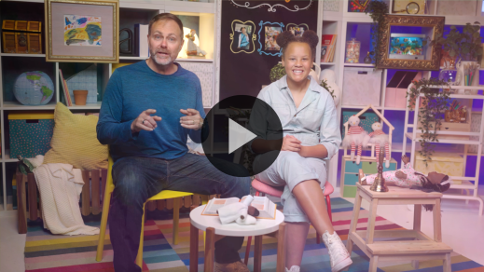

What a great story! Zechariah and Elizabeth’s baby, John, was also related to Jesus. The Bible says John the Baptist prepared the way for Jesus, which is such an important job. This story shows us that we can always trust God to hear our prayers.

**Response Time**

*Play a worship song quietly.*

Let’s respond to what we’ve learned today. Place your hands over your mouth like you can’t talk. Do you think Zechariah prayed to God when he couldn’t talk? *(Group response)* I think he did. Did you know God always hears our prayer even when we only think it? *(Group response)* Let’s pray that way today. I want you to repeat what I say by thinking the words in your head. Don’t say them out loud.

• *Pause so the kids can repeat phrases of the prayer silently after you.*

|  |
| --- |
| *Dear God, thank You for always hearing our prayers. We know we can always trust You. You love us and want good things for us. Help us to trust You. Amen.* |

**Faith Verse**

Okay you can talk again. God loves it when we learn Bible verses from His Word, and I love practicing Bible verses with you. Let’s say our Faith Verse and do the actions together.

[Psalm 34:19](https://ref.ly/logosref/Bible.Ps34.19) (NLT)

The righteous person faces many troubles, but the Lord comes to the rescue each time.

• *Show the* ***Faith Verse Video****.*

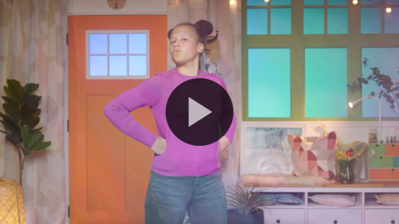

**Psalm** *(hands at waist, spread apart, palms up and out)*

**34:** *(hands together like a clap)*

**19** *(hands opened to “book”)*

**The righteous person** *(hands on hips with triumphant look on face)*

**faces many troubles,** *(fists up to chin with scared look on face)*

**but the Lord comes to the rescue** *(run in place)*

**each time.** *(jump once with each word)*

**Closing**

Today has been such a great time learning more about God. Who always hears us when we pray? *(Group response)* Yes, God! Our Bible story about Zechariah and Elizabeth taught us that so well. We have to trust God to answer our prayers. In Zechariah and Elizabeth’s case, they had to wait a long time for the answer to come. It may have been hard for them to believe while they were waiting. Our Faith Fact helps us remember that, doesn’t it?

• *Play the* ***Faith Fact Sound*** *video (bell ringing).*

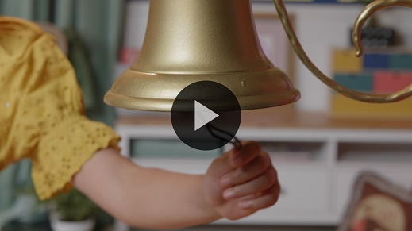

That sound means it’s time to practice our Faith Fact one more time: **I can trust God to answer**.

• *Show the* ***Faith Fact Slide.***



Let’s start out by saying it as softly as we can. *(Lean in and whisper.)* **I can trust God to answer**. Now, let’s say it a normal voice. **I can trust God to answer.** Finally, let’s say it as loudly as we can! **I can trust God to answer.**

**Dismissal to Small Groups**

That sounded so great! I’ve had so much fun with all of you, and now you get to join with your friends in small groups.

• *Dismiss the kids by groups.*

|  |
| --- |
| ***Leader Tip:*** *This can be done by assigning color teams or by age groups. Note that some young preschoolers may not know their age. Using a colored sticker, jersey, or wristband will help separate the kids and help identify their small groups.* |

**Small Group**

**25 Minutes**

*See supplies and prep instructions at beginning of session or in each activity below.*

|  |
| --- |
| ***Leader Tip:*** *Small groups can alternate to each circle, or all groups can do each activity at the same time. If you choose to alternate, you will need at least one leader per circle.* |

**Circle 1**

**Group Connection**

**Quiet Zone**

|  |
| --- |
| ***You Will Need***  *• Jingle bell, one per kid*  *• Yarn*  *• Scissors*  ***Getting Ready***  *• String one bell on a length of yarn for each kid.* |

In our Bible story today, we learned about a couple named Zechariah and Elizabeth. God gave them a promise that really surprised them. In fact, Zechariah was so surprised that God would give them a baby that he questioned if it would happen. From the time of this promise until their son John was born, Zechariah couldn’t talk. How many of you have a younger brother or sister? *(Group response)* Did it take a long time or a short time for your mom to have the baby? *(Group response)* Can you imagine not being able to talk the whole time you had to wait? *(Group response)*

God wanted Zechariah and Elizabeth to trust Him and His promise. Our Faith Fact teaches us that we can trust God to answer. Sometimes God may take a while to give us an answer. And sometimes it may not be the answer we want. But we know His answers are always true, His answers are always best, and He always does what He says He will do. Can you say our Faith Fact with me? **I can trust God to answer.**

• *Give each kid a jingle bell.*

Here’s why you have a jingle bell. I’ll give you some actions that I want you to do. Like Zechariah couldn’t make any noise, you must stay as quiet as you can while you move. If your jingle bell rings, you have to pause and say our Faith Fact out loud. Let’s try this!

• *Lead kids through actions (e.g., jump up and down, spin around, walk on your tiptoes, etc.)*

• *Remind kids to stop and say their Faith Fact when their bell makes noise.*

That was amazing! Was it easy to keep your bell quiet? *(Group response)* I think it was hard for Zechariah to be quiet all those months. God did exactly what He had promised. Zechariah and Elizabeth had a baby. Let’s all shout our Faith Fact together as loudly as we can. Ready? **I can trust God to answer.**

**Circle 2**

**Activity Page Time**

**Connected Answers**

|  |
| --- |
| ***You Will Need***  *•* ***Small Group Activity Page****, one per kid*  *• Pencils or pens, one per kid*  *• Crayons or markers*  ***Getting Ready***  *• Print copies of the* ***Small Group Activity Page****, one per kid.* |

In our Bible story, what had Zechariah and Elizabeth been asking God for? *(Allow responses.)* They had asked for a baby. They had grown to be old, and they still didn’t have the baby they had prayed for. Do you think it was easy for them to wait for God to answer their prayer? *(Group response)* I don’t think it was easy for them at all. Our Faith Fact says **I can trust God to answer.** They probably thought God said no to them having a baby. God surprised them! Do you remember how God answered Zechariah’s prayer? *(Group response)* Let’s see if you’re right.

• *Hand out a copy of the* ***Small Group Activity Page****, a pencil, and crayons to each kid.*

On your Activity Page, you can see two pictures and a lot of dots. Look at the picture on the left. Your job is to start at the dot that has a number 1 by it and draw a line connecting it to the other dots in order. The next dot you connect to will be the number 2 and then the number 3. Next, connect the dots with letters next to them. You’ll connect all the numbers and letters in order until you make a picture that will show us how God answered Zechariah.

• *Allow time for kids to complete the angel picture.*

What picture did you make? *(Allow responses.)* God sent an angel to give His answer to Zechariah and Elizabeth. Trace the word *angel* under the picture.

• *Allow time for kids to trace the letters.*

We can trust God to answer our prayers. Do you think He will send an angel to talk to us? *(Allow responses.)* It’s possible, but probably not. Let’s connect the dots in the other picture to see how we know we can trust God to answer us when we pray. Remember, start with the number 1. When you’re done, it will make a picture of something that helps us find answers from God. Then, trace the letters of the answer.

• *Allow time for kids to complete the Bible picture.*

Wow, you all did that so quickly! Who can tell me what the picture is? *(Allow responses.)* It’s a Bible! The Bible is filled with many answers for life. It’s just one of the ways that we can find answers from God. Another way is when we spend time in prayer. No matter how you spend time with God, it’s important to remember this truth. We can trust God to answer us. Let’s finish coloring the pictures.

• *During the activity, interrupt and practice the Faith Fact:* **I can trust God to answer.**

• *Play the* ***Faith Fact Sound*** *video. Review the Faith Fact even if you can’t play the sound.*



**Circle 3**

**Feet-to-Floor Game Time**

**Faith Verse Freeze Tag**

|  |
| --- |
| *No prep needed for this activity.* |

Who is ready to play a fun game? *(Group response)* Great! Our game today requires us to remember our Faith Verse. Raise your hand if you remember what it is. *(Group response)* It’s not an easy verse to learn. Let’s practice it. Repeat it after me.

• *Lead kids through Faith Verse with actions two or three times.*

**Psalm** *(hands at waist, spread apart, palms up and out)*

**34:** *(hands together like a clap)*

**19** *(hands opened to “book”)*

**The righteous person** *(hands on hips with triumphant look on face)*

**faces many troubles,** *(fists up to chin with scared look on face)*

**but the Lord comes to the rescue** *(run in place)*

**each time.** *(jump once with each word)*

That was really good! Our Faith Verse teaches us that when we face troubles, the Lord will rescue us. For our game today, we’ll play Freeze Tag. One of you will be “It.” When the game starts, everyone will move around the room. If you get tagged, you have to freeze in place. You must stay frozen until somebody unfreezes you.

Are you up for an extra challenge to unfreeze your friends? *(Group response)* The way that you get unfrozen is by saying the first part of our Faith Verse: “The righteous person faces many troubles.” Say that after me. *(Group response)* Then the person unfreezing you will say the second part of our Faith Verse: “But the Lord comes to the rescue each time.” Say that after me. *(Group response)* Let’s play!

• *Optional: If your group is mainly younger kids, you may want to use the Faith Fact instead.*

• *Allow kids to play the game for as long as time permits*

That was amazing! I loved watching you all have fun while learning the Word of God. Learning Bible verses is one of the most important things we can do. Great job!

**Circle 4**

**Hands-On Learning**

**Phone Calls**

|  |
| --- |
| ***You Will Need***  *• Smartphone*  *• Someone ready to answer your call*  ***Getting Ready***  *• Ask someone to be ready to answer the phone when you call. They don’t have to be present in the room.* |

Raise your hand if you’ve ever talked on the phone. *(Group response)* Who did you talk to? *(Allow responses.*) When you talk on the phone, can you see the person you’re talking to all the time? *(Group response)* Sometimes we can see who we talk to, but most of the time we can’t. Let’s make a phone call now.

• *Call the person you arranged to speak to.*

• *Put your phone on speaker so everyone can hear.*

One at a time, I want you to say, “Hi,” and ask a question. After you do that, let’s listen carefully for my friend’s answers.

• *Allow each kid to ask a question.*

• *Say goodbye and end the call.*

You couldn’t see the person on the other end, but every time you asked a question you got an answer. The same is true with God. We can’t see God, but when we spend time with Him and listen for His voice, He will always answer us in some way. Sometimes He will give us the answer we want to hear very quickly. Sometimes He listens to us, but it takes a long time for His answer like for Zechariah and Elizabeth. Sometimes His answer isn’t what we want to hear. But, we can always trust God to answer us.

**Dismissal**

• *Play the* ***Faith Fact Sound*** *video (bell ringing)****.***



• *Show the* ***Faith Fact Slide.***



Wow! I can’t believe that our time together is already almost over. Before we go, can we say our Faith Fact together one last time? **I can trust God to answer.** Fantastic! I had a great time learning more about God’s Word with you. See you next time!

• *Send home the* ***Small Group Activity Page*** *with each kid.*

• *Remind parents that there are* ***Family Devotions*** *available on the app to do with their kid.*

• *Tell everyone the date and time for the next session.*